**How to Save Emergency Contacts in Kronos – 6 Clicks!**

1. **Once logged into Kronos, click the hamburger menu in the top left hand corner.**

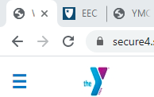

1. **Click the single person, then my information.**

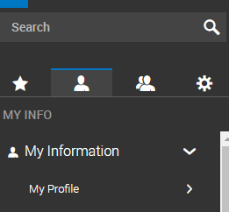

1. **Click my profile > my profile. This will bring you to your profile page.**

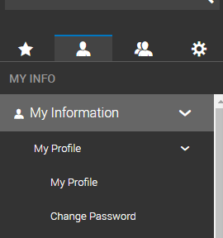

1. **Scroll down then to the right to account contacts, and click add contact.**

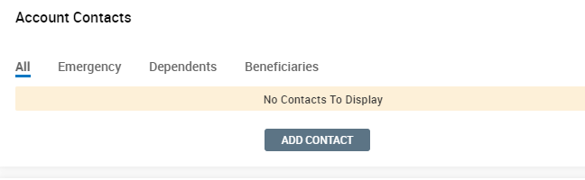

1. **Check off “Emergency” as contact type, then complete the required information and press save.**

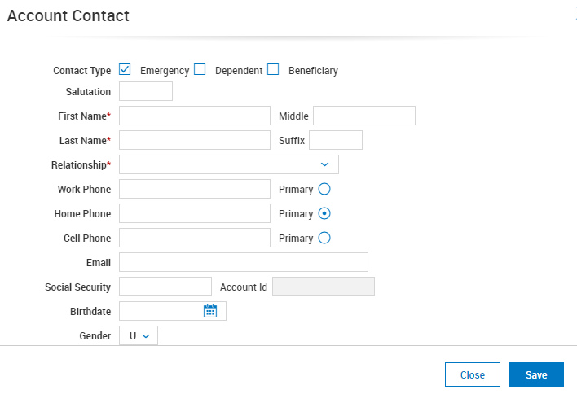

1. **Once you click save, the emergency contact will be saved to the profile.**