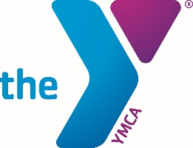**4th of July**

Greetings Family, Friends and Co-Conspirators:

In this time of the Coronavirus and awakened social consciousness, we are forced to confront daily challenges to our physical and spiritual well-being.

To protect our physical well-being, we must wear facial coverings, regularly wash our hands, and maintain safe distances from one another.  These prudent acts are intended to keep us and others safe from CV-19.  Spiritually, we continue to awaken ourselves to the injustices experienced by Black and Brown men and women across America as a result of systemic racism.

And now, on the eve of the 4th of July, we are confronted by the intersection between the ideals set forth in the Declaration of Independence and the impact of the Coronavirus and racism in America.  We are reminded of the work yet to be done and the promise of tomorrow.  A tomorrow that many have been crying for since their first breaths, while others cry for in their last breaths.

What is promised . . . “We hold these truths to be self-evident, that all men (and women) are created equal, that they are endowed by their Creator with certain unalienable Rights, that among these are life, liberty and the pursuit of Happiness . . .”  On July 4, 1776, when these truths were declared, the oppressor and tyrant was England.  Today, the oppressor and tyrant is racism and its prime weapon is poverty.

Normally, I would outline the multitude of ways in which we, as a community-based organization, in partnership with others, address poverty and racism in our work as servant leaders.  And while I am extremely proud of what we do each and every day in service to others and while I am overjoyed by our steadfast commitment to positive social change, today I am saddened by the reminder that the unalienable rights set forth in our Declaration of Independence are not shared by all; in fact, today, it is neither truthful nor self-evident that “all men (and women) are created equal, with the right to life, liberty and the pursuit of happiness.”

For many, the reality of America is poverty, despair, discrimination, incarceration, homelessness, hunger, nullification, unemployment, under-education, illness and more – the opposite of life, liberty and the pursuit of happiness.  No one articulates the disparity between the America we hope for and the America in which we live better than Frederick Douglass’ message on July 4, 1852 entitled, “What to the Slave is the Fourth of July?”  I invite you to read it.  Frederick Douglass was a former slave who became one of this country’s greatest abolitionists.

Frederick Douglass challenged us to work toward the ideals upon which this country was founded, and that is our work in these challenging times.  Let’s not be distracted by the Coronavirus, but take what it has uncovered – health disparities among folks of color; let’s not be distracted by political polarization, but take what it has uncovered – the need to register and vote; let’s not be distracted by our sorrow, but take what it has uncovered – the need to turn our sorrow into constructive action; and let’s not be distracted by today, but take what it has uncovered – the need to build a more equitable and inclusive tomorrow.

America has great promise.

Permit me to close with two messages:

*"If there is no struggle, there is no progress. Those who profess to favor freedom and yet deprecate agitation are men who want crops without plowing up the ground; they want rain without thunder and lightning. They want the ocean without the awful roar of its many waters."*

*Frederick Douglass*

*August 3, 1857*

*Canandaigua, New York*

*“Like slavery and apartheid, poverty is not natural. It is man-made and it can be overcome and eradicated by the actions of human beings. And overcoming poverty is not a gesture of charity. It is an act of justice. It is the protection of a fundamental human right, the right to dignity and a decent life. While poverty persists, there is no true freedom.”*

*Nelson Mandela*

*February 3, 2005*

*London, England*

Enjoy the 4th of July and the promise it embodies.

Yours in fellowship and service,

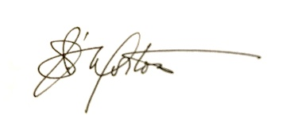

James Morton, Esquire  
President/CEO  
YMCA of Greater Boston